Roasted Cauliflower with Pumpkin seeds, Brown butter and Lime

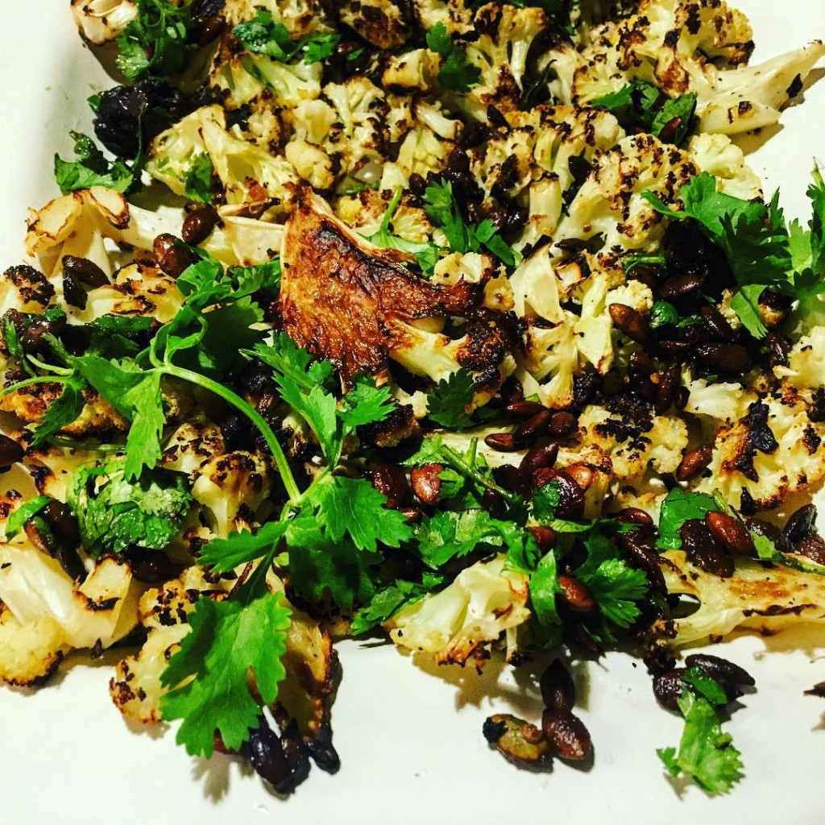

I posted this pic on Instagram over the weekend after I made it and got lots of positive feedback and requests for the recipe!  Bon appetit!

Ingredients:  
2T olive oil, divided  
1 large head of cauliflower  
2T unsalted butter  
1/4C raw shelled pumpkin seeds  
1/2tsp crushed red pepper flakes  
1/4C chopped fresh cilantro, plus extra stems for serving  
1T fresh lime juice

Method:  
Preheat oven to 450°. Coat a large rimmed baking sheet with 1T olive oil. Trim cauliflower stalk and place head stalk side down on a cutting board. Slice cauliflower lengthwise into half inch slices.  
Arrange cauliflower slices and any stray pieces in a single layer on prepared baking sheet. Drizzle with 1T oil and season with salt and pepper. Roast until underside is deeply browned, 20 to 25 minutes. Turn cauliflower over, season with salt-and-pepper again and continue to roast until the other side is dark brown and crisp, 15 to 20 minutes longer.  
Meanwhile, melt butter in a small skillet over medium. Add pumpkin seeds, bring to a simmer and cook, swirling pan occasionally, until pumpkin seeds are toasted and butter is browned and smells nutty, about 6 to 8 minutes. Remove from heat and add red pepper flakes, let cool for 10 minutes. Add chopped cilantro and lime juice, season with salt and pepper. Arrange cauliflower on a serving platter and drizzle with dressing, serve topped with cilantro leaves.